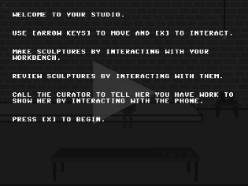
When you’re happy with your work you can always use the phone and call the curator
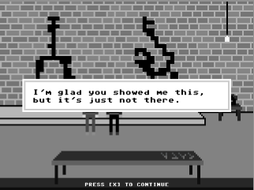
“Say what? This is some of my best work.”
Can the curator walk in? She arrives so quickly and is covered by the voice box before you really get to see her or understand she is there.

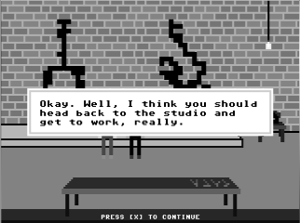
Given that you are in the studio these scripts need adapting.
Say:
“Okay, Well, I think you should get back to work on this stuff, it has real potential.”

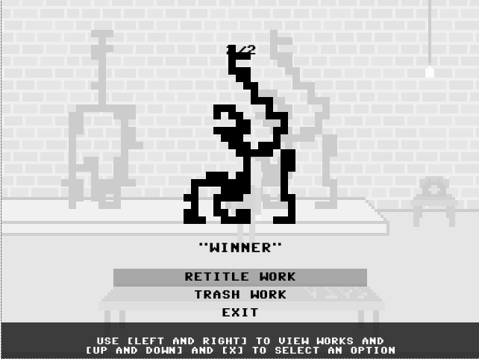

I got into a loop when I retitled and exited. The only course open to me then was to retitle the same work again
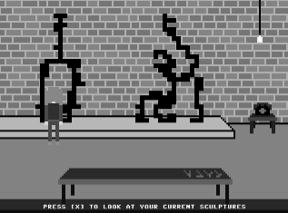
Tried going over to the other sculpture but when I pressed [x] it still took me back to ‘Winner’ the one I had renamed before. So pressing [x] doesn’t take me back to my “current sculptures” just one of them (the renamed one).
And I’m still smarting over that fucking curator not seeing how good they are too.
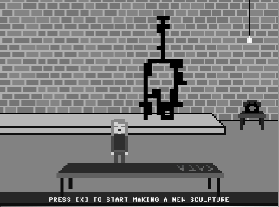
OK I trashed “Winner” (tragedy) and renamed “Hunger Games” and will make another work. Assume you can only make two.
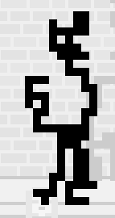
Damn I’m good.
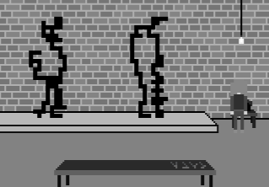
When I made a third work I seemed to loose my first one.
Still I think my work is TERRIFIC! I’ll get that snotty curator on the phone and tell her to move her sorry ass over here.
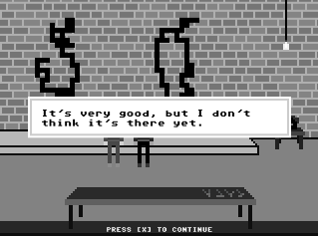

WHAT!!!! Oh PLEASE.
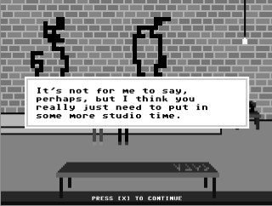
Yeah, and you need to lose some weight.
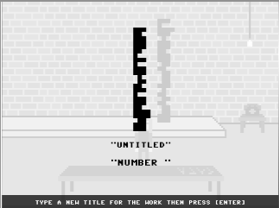
See you can’t use numerals in your titles…
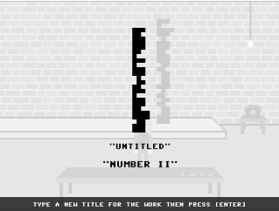
Probably doesn’t matter. But seem to have an untitled caption stuck in here for some reason. My fault – didn’t press return to get the title into the system.
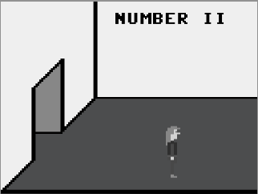
That curator knows a thing or two, can’t wait to see my… I mean the show.
Couldn’t see why “Number 11” was on the wall. Maybe this could be the name of the exhibition “Contemporary Now!” or something generically inspiring.
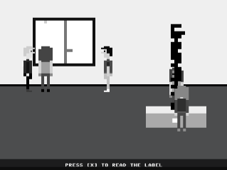
Wow, both my works are in the show. I thought she said only one…maybe a script change, can’t remember the exact words but that was the impression I got.
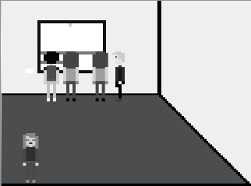

Might be nice to have an artwork or signage (name of the show?) on the back wall.

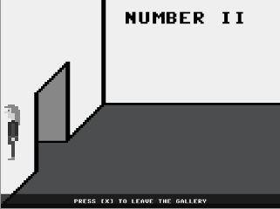

As I waked out the door the wall became transparent.

Like the idea of Artforum coming up at the end. Is it going to be the cover? Can you manage to get one of the works on the cover? That would be very cool.

Will have a break and do a spot of painting later in the day.

